1……pulled and create the container from ubuntu image

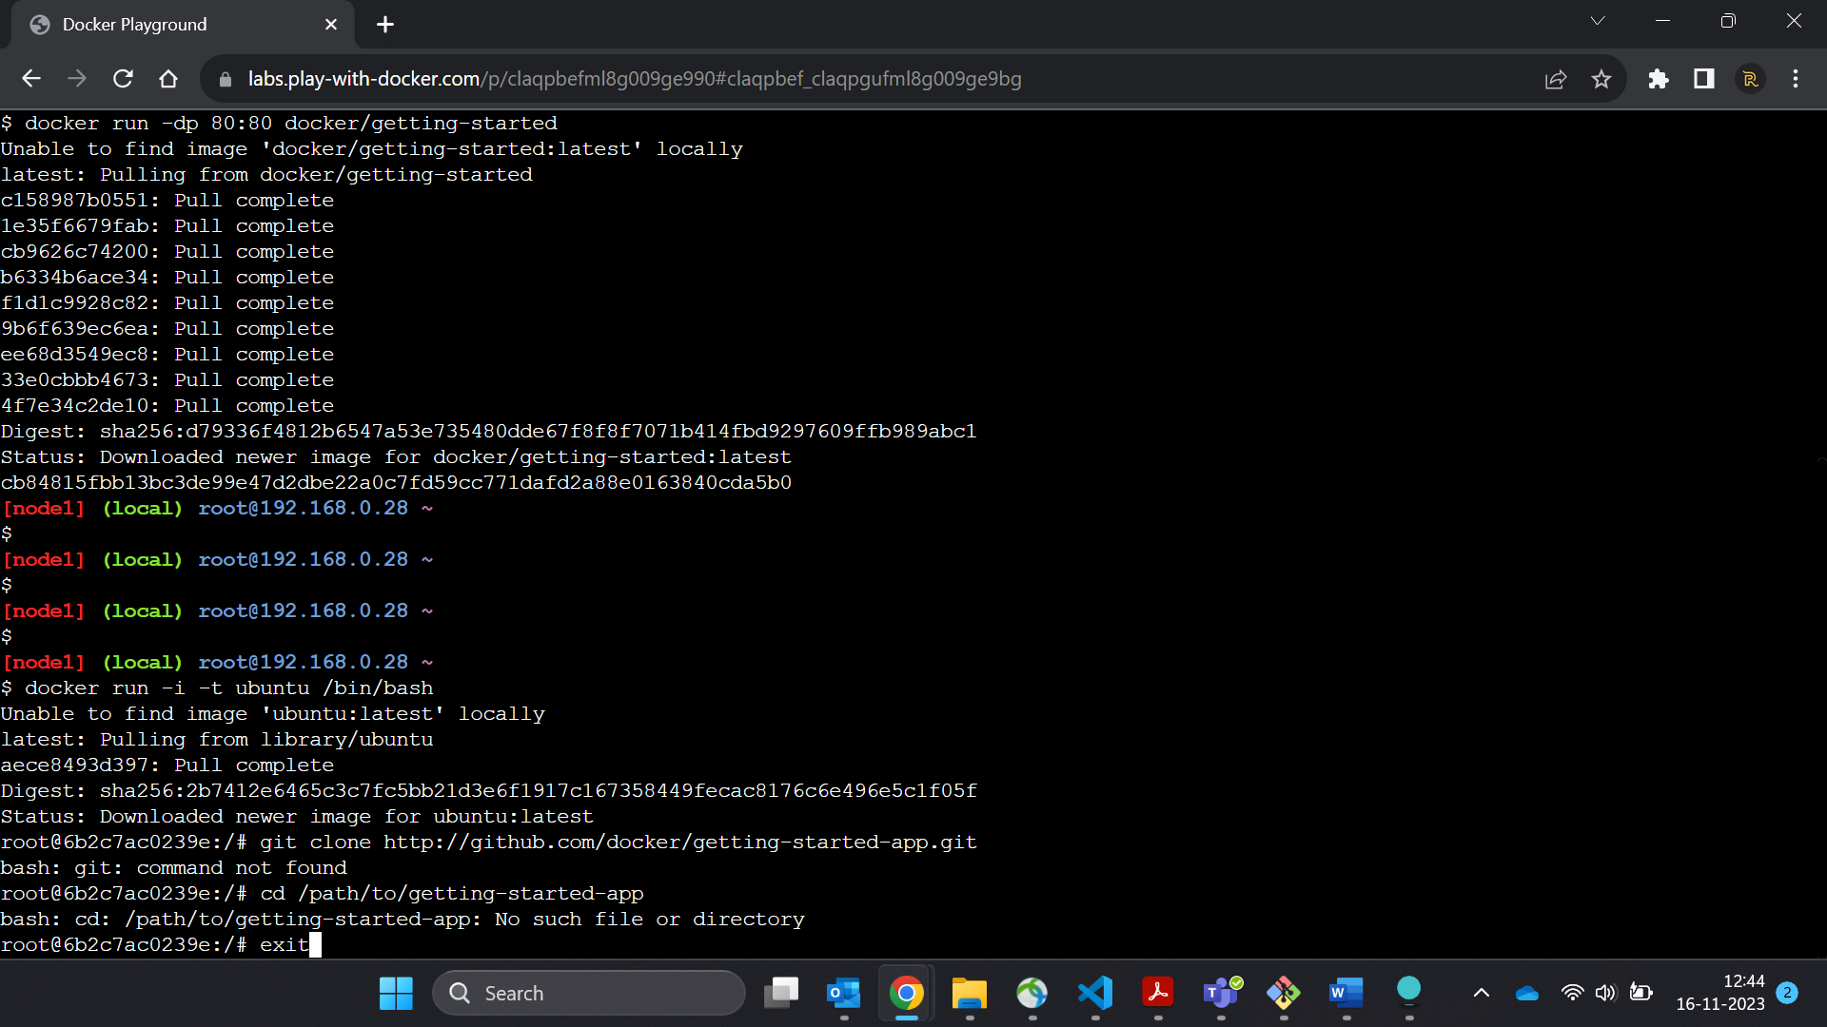

2…Before you can run the application, you need to get the application source code onto your machine.

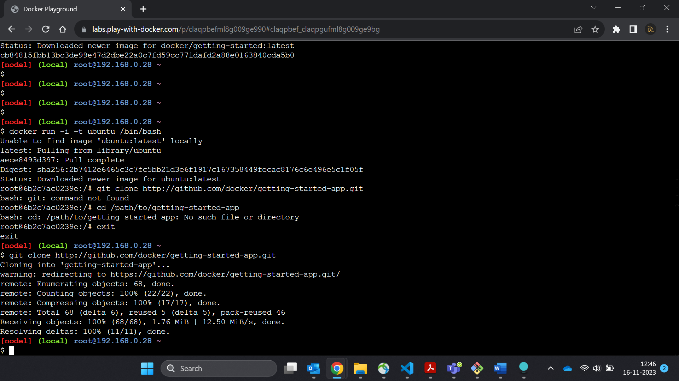

3………Create an empty file named Dockerfile.

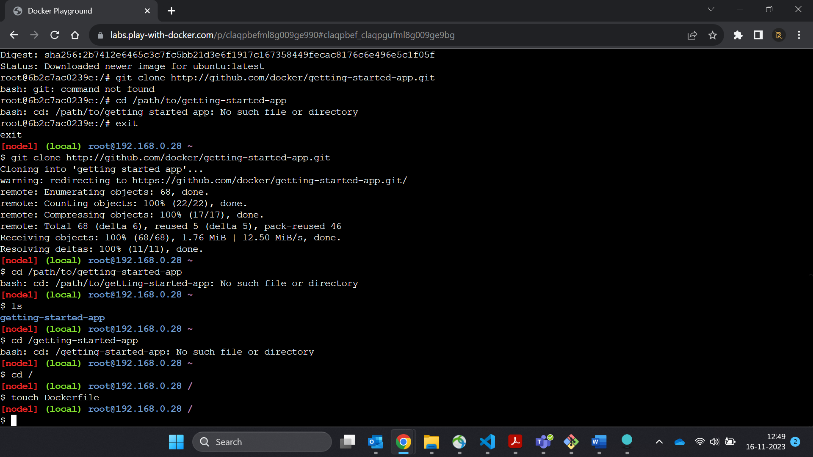

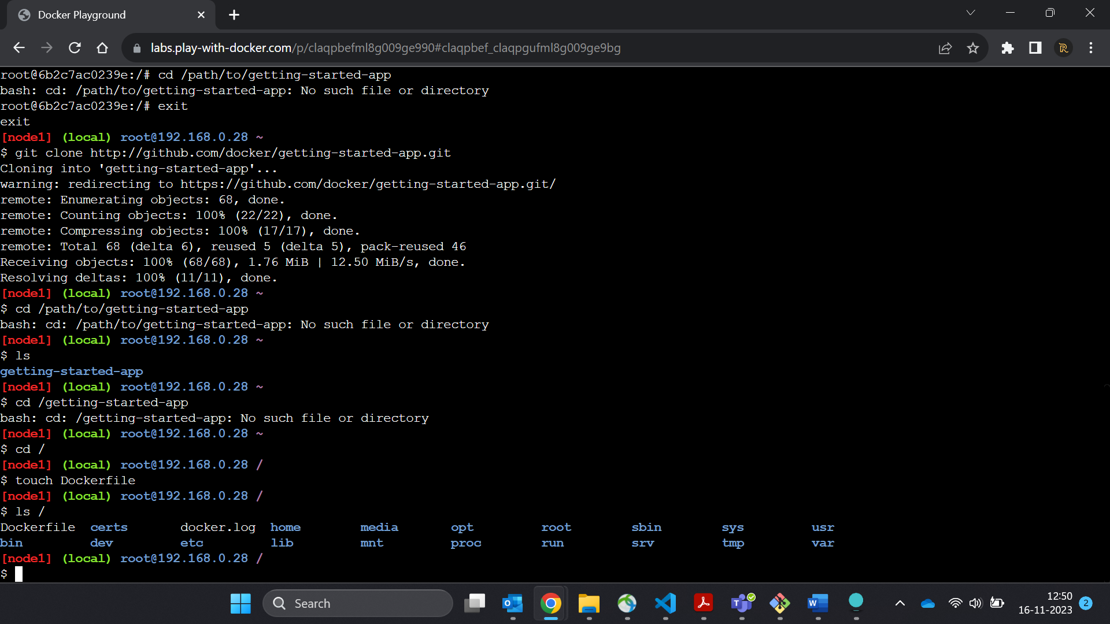

4…..

Build the image.

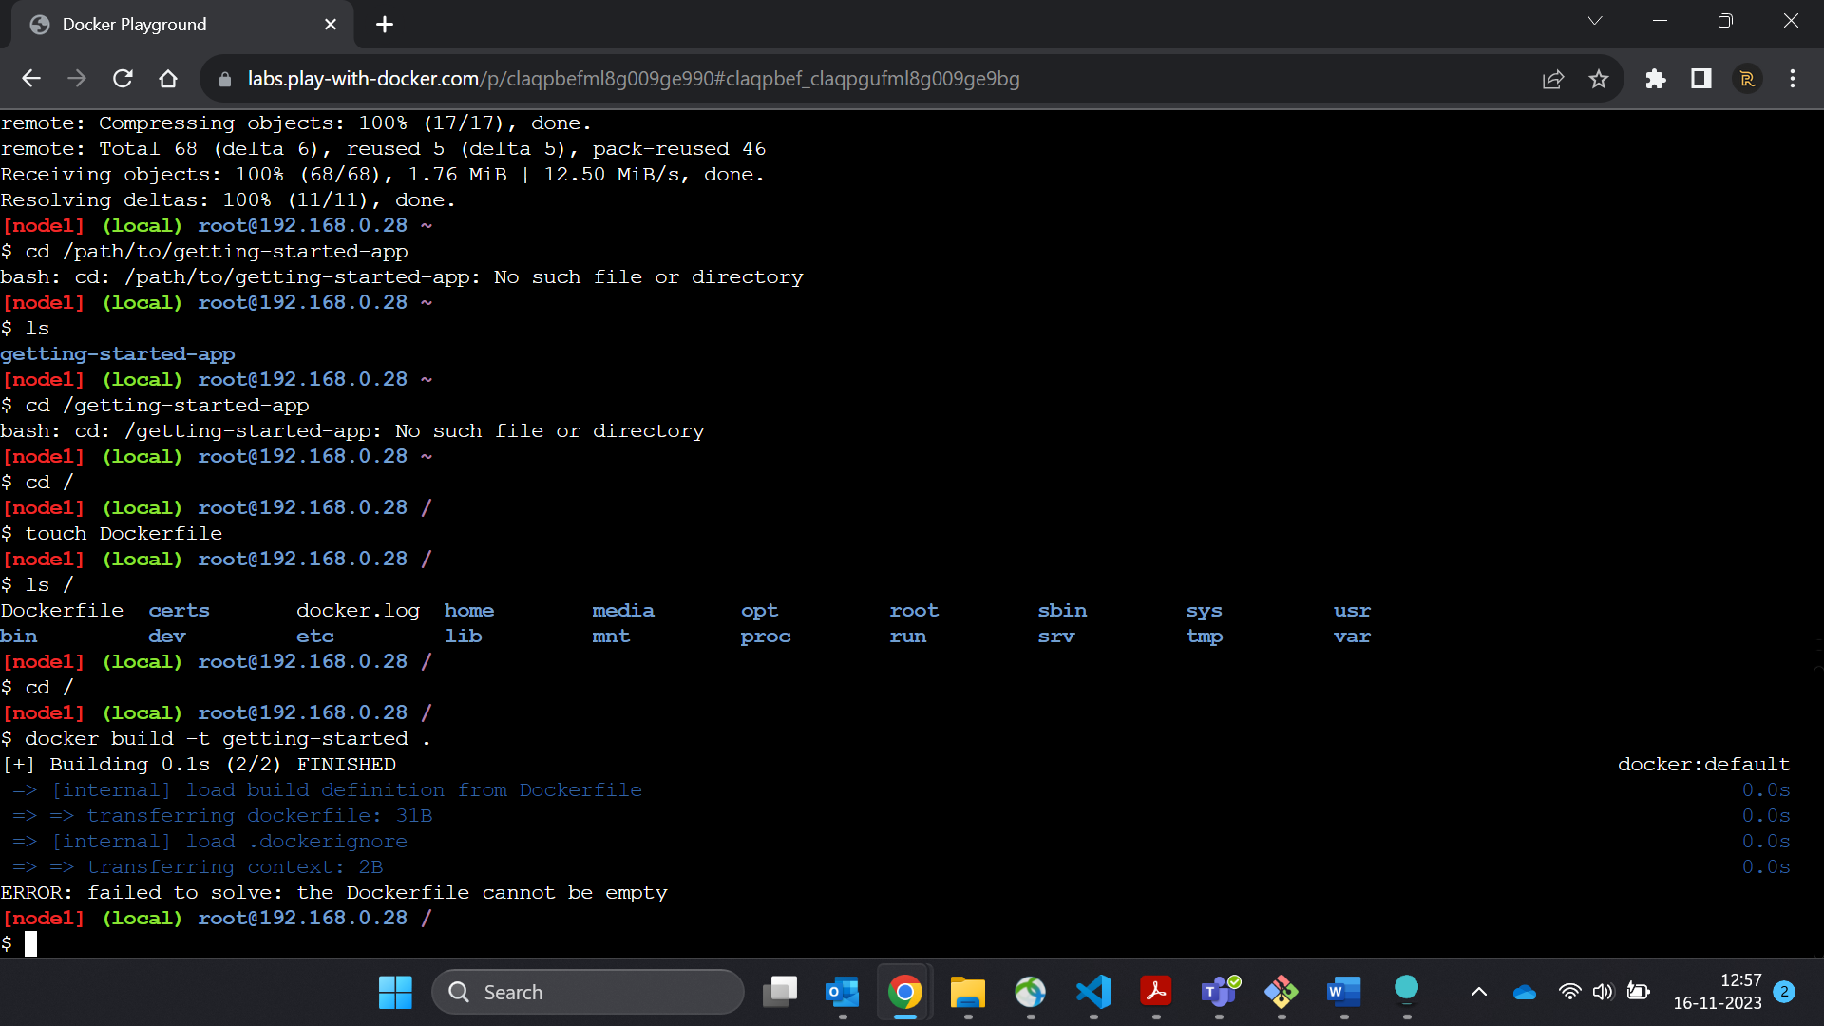

It will build the image of your project files from the current directory…

4. Run your container using the docker run command and specify the name of the image you just created:

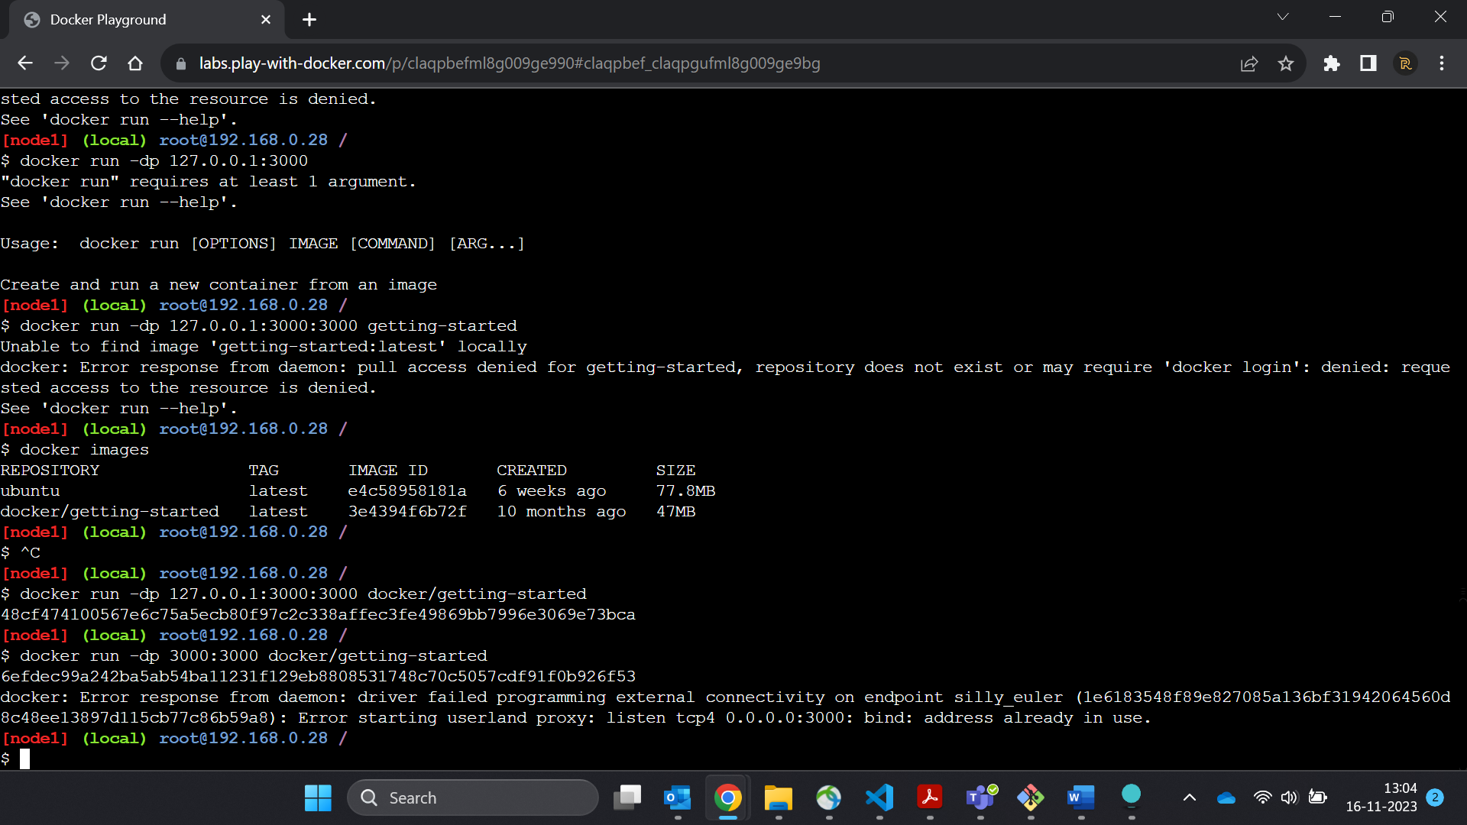

5..List all the container

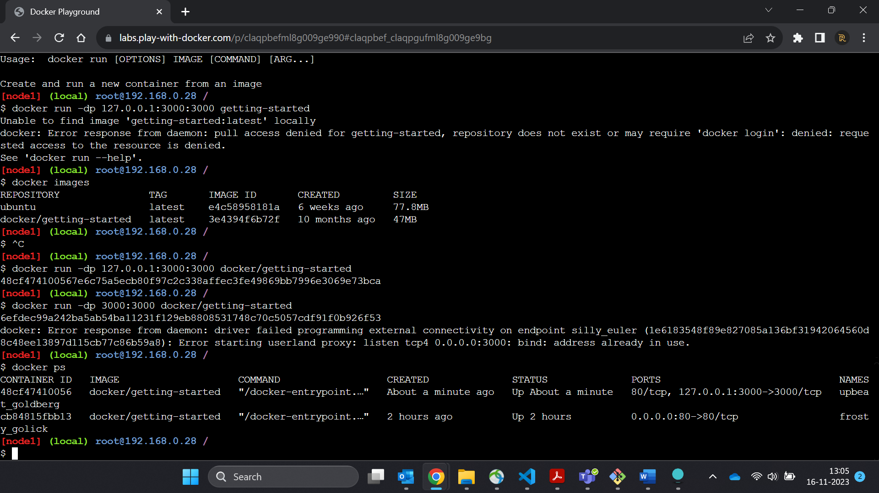

6..

1…In the PWD terminal, extract the zip file.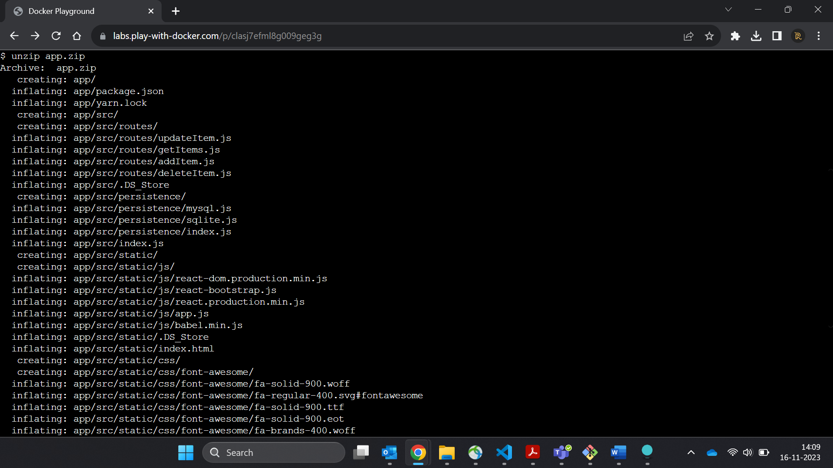

2. Change your current working directory into the new 'app' folder.

3. In this directory, you should see a simple Node-based application.

ls

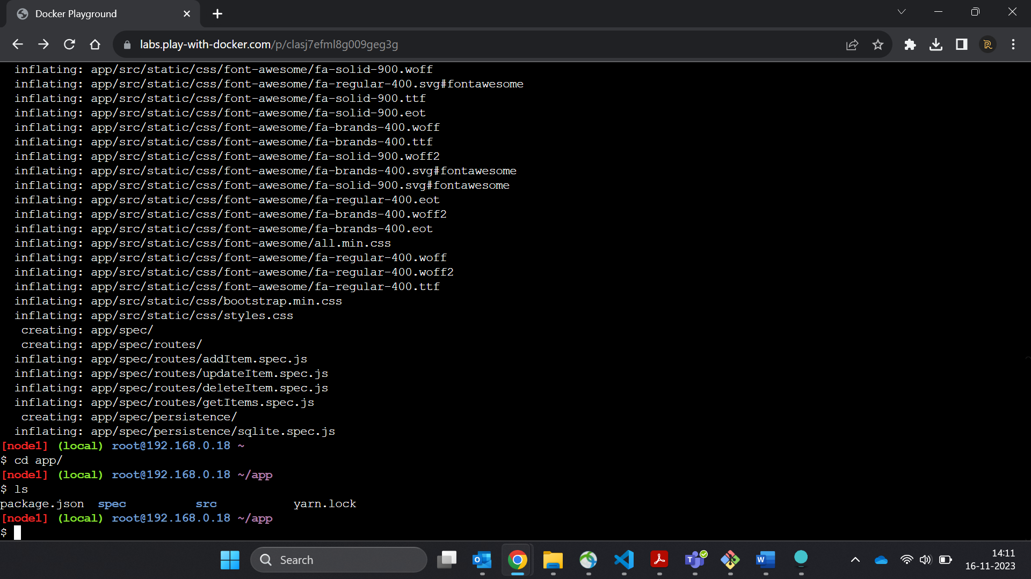

4. Create a file named Dockerfile with the following contents.

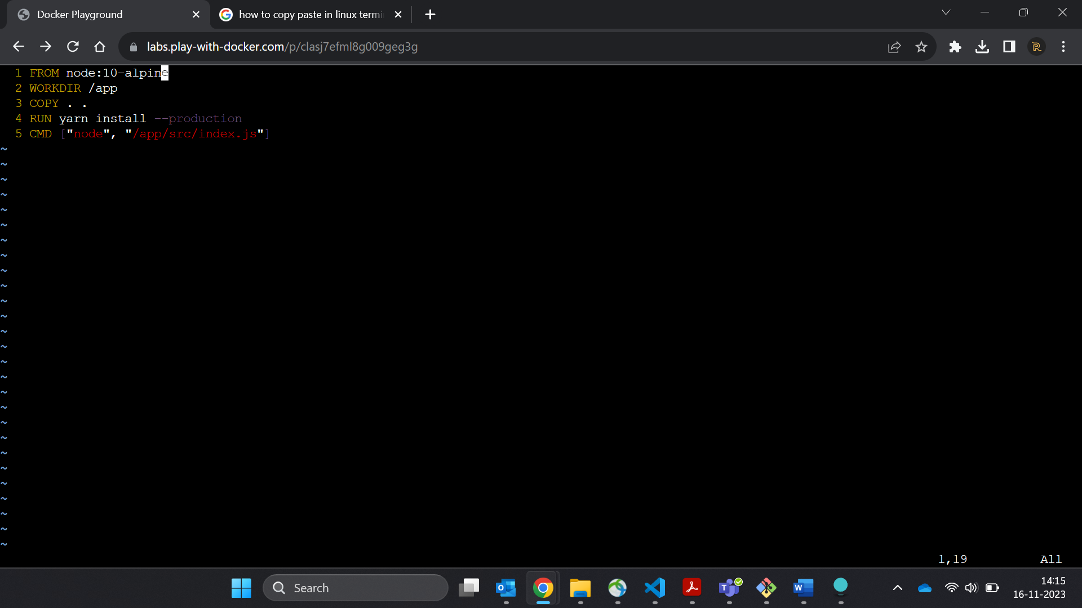

5. Build the container image using the docker build command

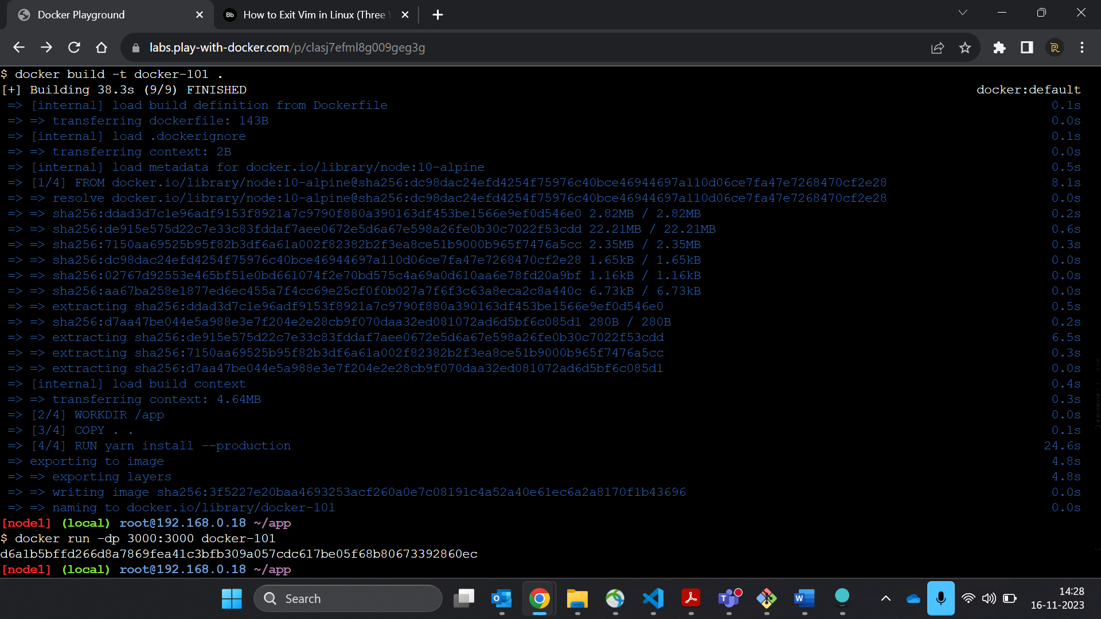

6…Start your container using the docker run command:

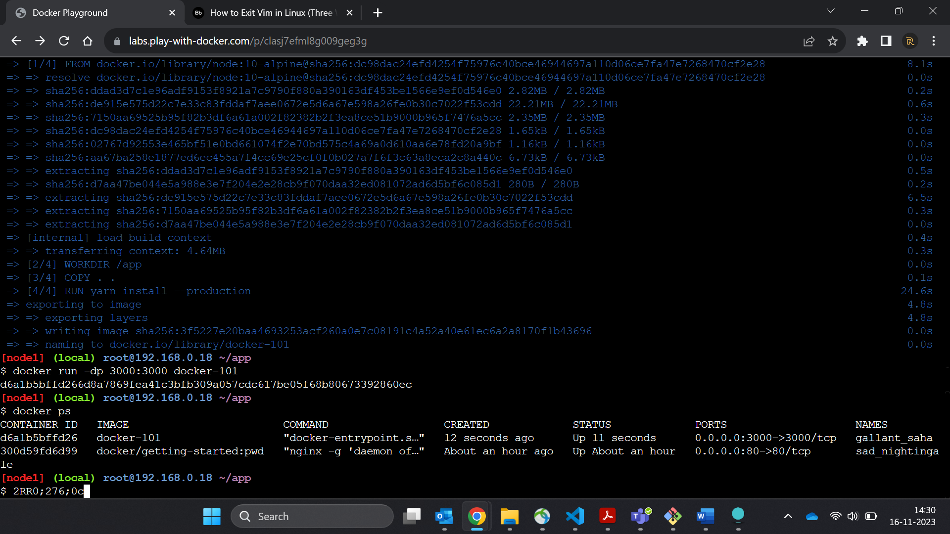

7….Open the application by clicking on the "3000" badge at the top of the PWD interface. Once open, you should have an empty todo list!

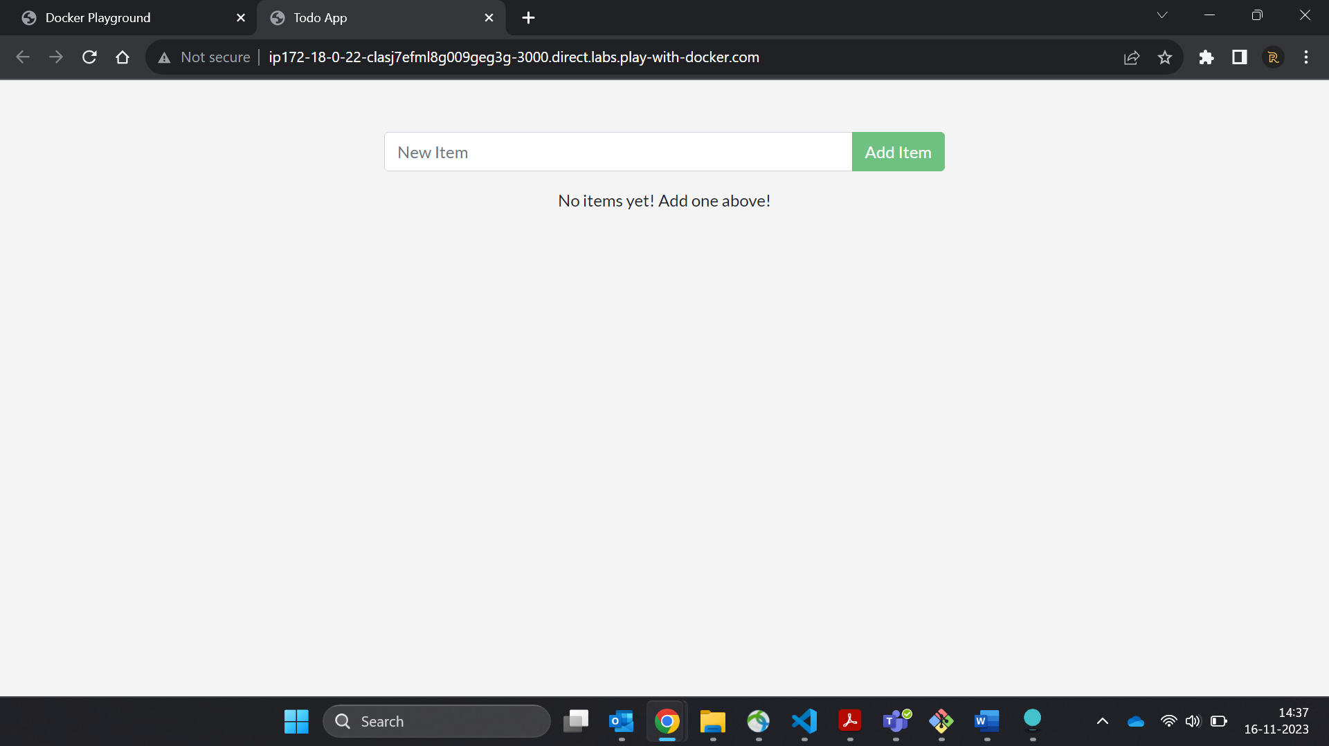

8…Go ahead and add an item or two and see that it works as you expect. You can mark items as complete and remove items

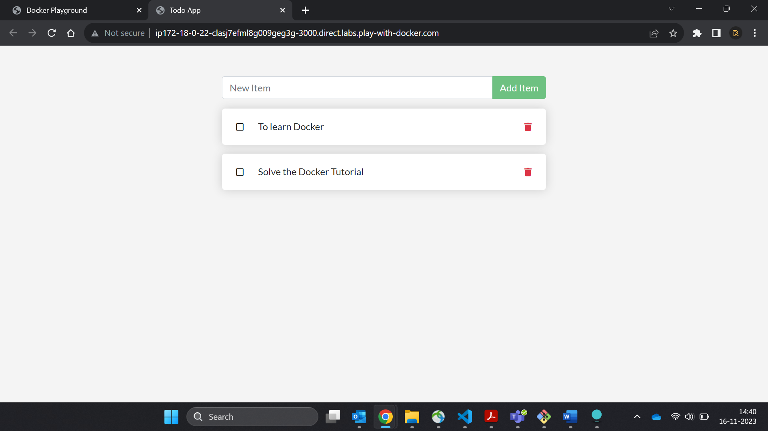

2……..SECTION

1. In the ~/app/src/static/js/app.js file, update line 56 to use the new empty text. ([Editing files in PWD tips here](http://ip172-18-0-22-clasj7efml8g009geg3g-80.direct.labs.play-with-docker.com/pwd-tips#editing-files))

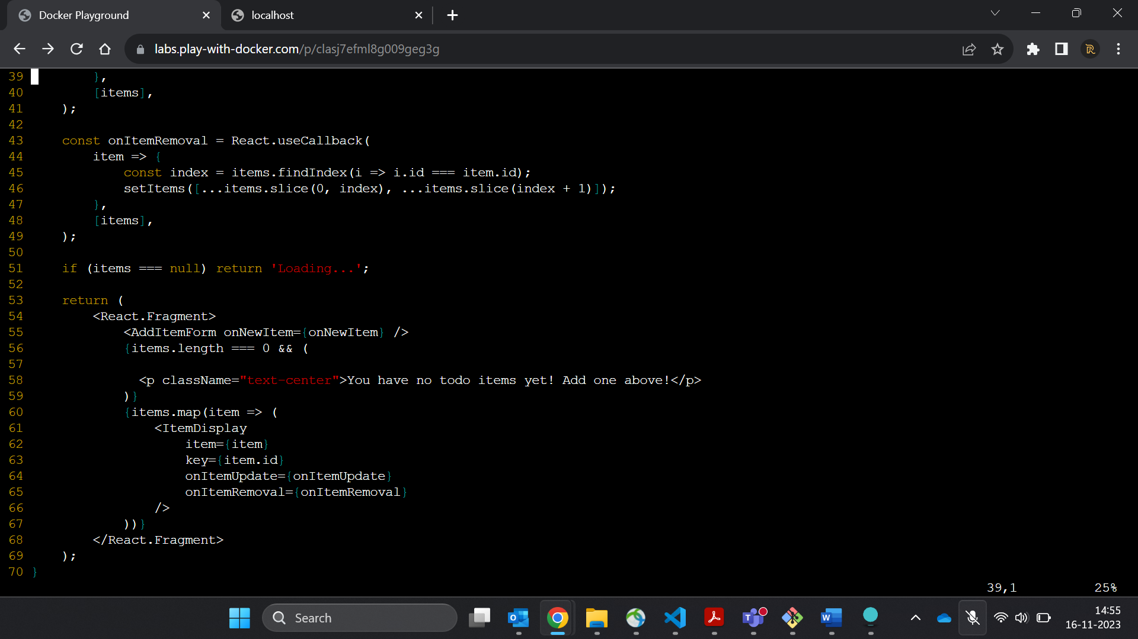

2.Let's build our updated version of the image, using the same command we used before.

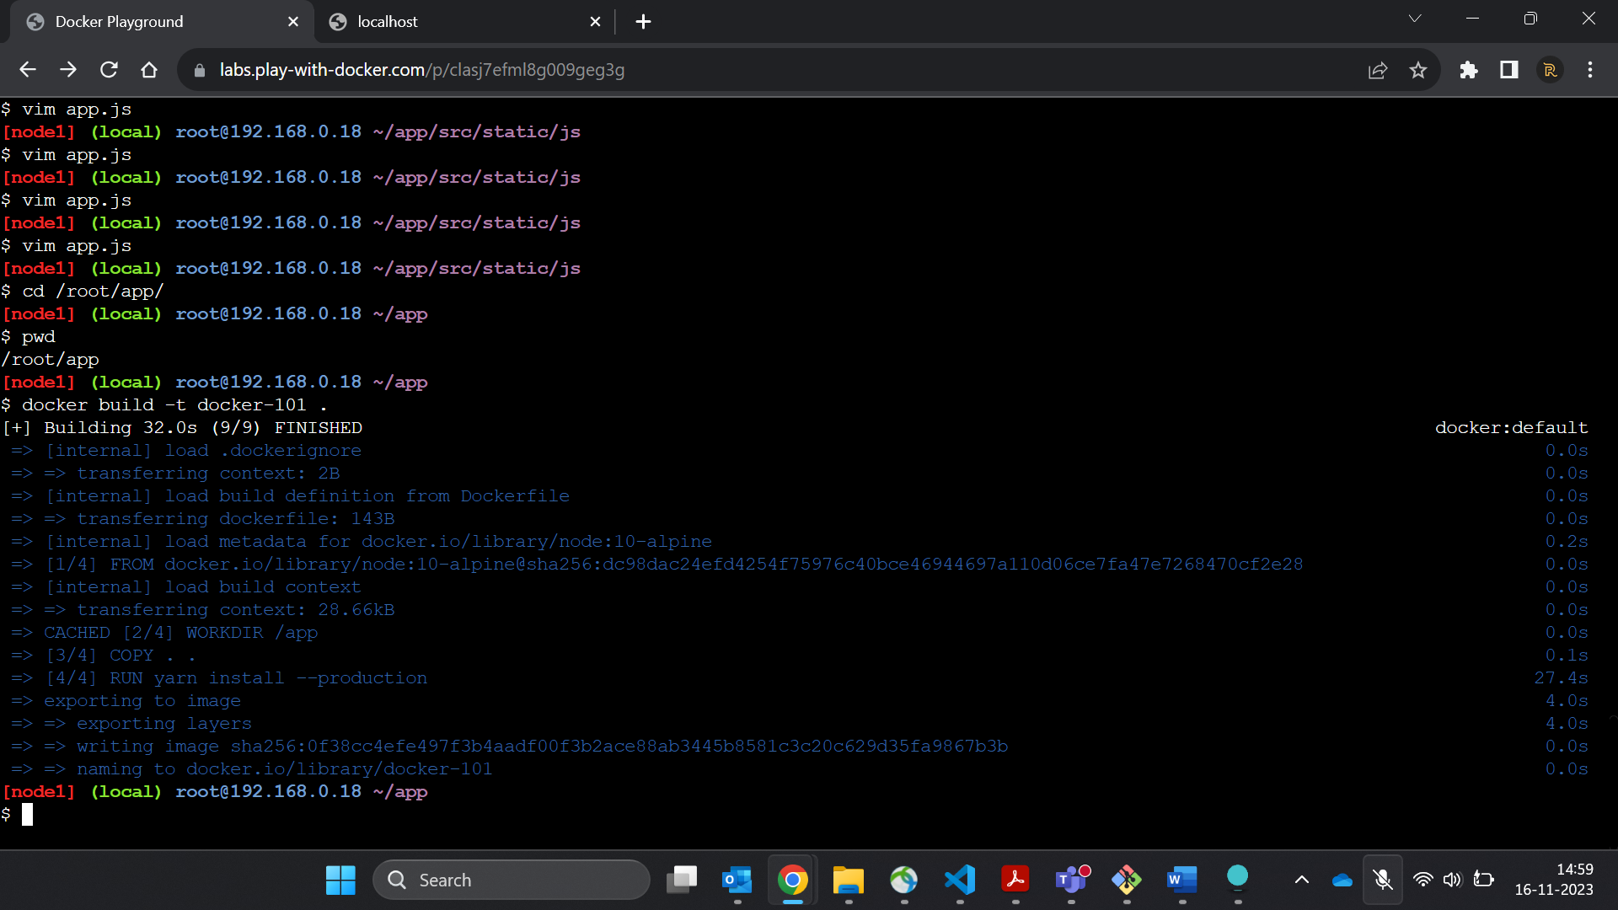

3. Let's start a new container using the updated code.

